**Take Home Test- FrontEnd**

Implement a single page application which has 2 views as show below:

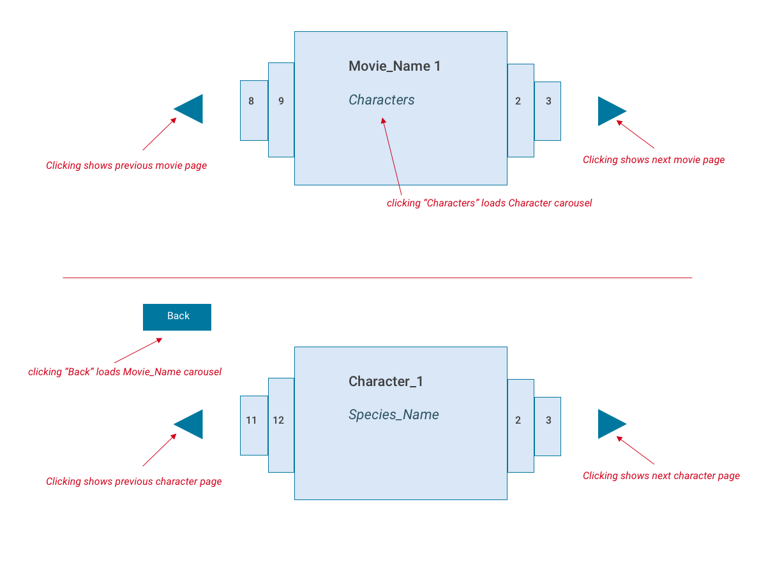

The first view carousel displays the movie names fetched from <https://swapi.co/api/films/>

response.results[n].title is the Movie_Name

The 2nd page displays the data from response.results[n].characters (where n is the movie index).

The Character (response.name) is fetched from [https://swapi.co/api/people/***CHARACTER_NUMBER***/](https://swapi.co/api/people/CHARACTER_NUMBER/)

The ***CHARACTER_NUMBER*** is extracted from the characters array from the previous request (1st request).

The Species_Name (response.name) is fetched from [https://swapi.co/api/species/***SPECIES_NUMBER***/](https://swapi.co/api/species/SPECIES_NUMBER/)

The ***SPECIES_NUMBER*** is extracted from the species section of the previous request (2nd request).

--------------------------------------------------------------------------------------------------------------------------------------------------------

# Please upload the solution into github.

# Use whatever technologies you feel like. Example, for react boilerplate can use <https://facebook.github.io/create-react-app/>

# Please add unit tests.